Hobbyists Newsletter
Fall 2026
President – Peter Weinstein First Vice President – Steve Friedman
Second Vice President – Chuck Woehrle Secretary – Dick Boswell
Treasurer – Gary Engelhardt Church Liaison – Lew Dickinson
Sponsored by the First Presbyterian Church, Ridgewood, NJ
http://www.hobbyists-unlimited.com

Club Activities
Beer Appreciation
Rick Rosenthal, Chairman - rickcrosenthal@icloud.com, (201) 675-1870
Meet monthly at various venues to taste and savor a variety of beers, as well as enjoy snacks or meals.

Blackjack, Gin, Poker, Texas Hold’em
RayLitwitz, Blackjack Chairman – raylitwitz@gmail.com, (973) 714-9019
Dan Wolf,Gin and Texas Hold’em Chairman – danwolf@optonline.net, (201) 310-1237 Don Peterfriend, Hi-Lo Poker Chairman – dpeterfriend@yahoo.com, (201) 739-8672
Blackjack meets on the second and fourth Thursday at noon at various members’ homes on a rotating schedule. There are subs who attend when needed. It is a friendly game. New members are always welcome.
Poker players meet every Friday at members’ homes. On alternate Fridays we play Texas Hold'em then Hi-Lo Poker the following week. Hold'em is limited to eight players due to homeowner's table size. Hi-Lo Poker is limited to seven players.

Bocce
Steve Friedman, Chairman - stefri4@yahoo.com, (201) 916-6079
Bocce continues through the fall until it gets too cold to play outside, usually around mid-November. We have had as many as 13 Hobbyists show up to play and have had to split up to play on two bocce courts at Borough Park in Waldwick. Please join us - all you need to be able to do is roll a ball. Everyone gets to play. It's always a fun couple of ours. Fridays 9:30 - 11:30 a.m.

Book Club
Jon Sterling, Chairman – jsterling287@gmail.com, (201) 913-0439
Monthly book readings and discussions.
Bowling
Gary Don, Don Peterfriend, Mark Singer, Bill Raftery, Bob Mosher – Committee
The Hobbyists Bowling League commenced its fall practice season on September 9 at Montvale Lanes, with our usual 3 weeks of practice bowling. The actual season starts on September 30. This is due to other Hobbyist events taking place, which a lot of our bowlers attend.
The season will consist of the usual three 10-week sessions, which will end on April 28. Playoffs will begin occur during the first two weeks of May, ending on May 12. The League schedule will be published in September, before the League starts.
Because of increased interest from our members, we are adding one team to the League this year, for a total of 16 teams and 64 regular bowlers. The team rosters will be announced in September, once we finalize the additional team. Any member not already participating in our league, who is interested in bowling should contact any member of the bowling committee or just show up on a Wednesday morning at 9 a.m. at Montvale Lanes.

Bridge
Mike Murphy, Chairman – mgmclbchp@gmail.com, (201) 334-7284
Meets each Thursday at the church from 12 to 3:30 p.m. for duplicate bridge. Players are requested to sign in by no later than 11:45 a.m. in order to allow for team assignments.

Camera Club
Tom Heed, Chairman – theed@ramapo.edu, (201) 845-534-8695
Meetings include presentations on topics such as composition, lighting, equipment, and photographic techniques. The club holds an annual photography competition, during which outside experts are often invited to provide critiques and commentary. Contact Tom for specific meeting dates and times.

Cribbage
John Peterman, Co-Chairman – petermanj@wpunj.edu, (551) 777-0227
Don Dexter, Co- Chairman – donaldcdexter@gmail.com (917) 327-9390
Contact either John or Don for specific times and location.

Chess
Rick Pascal, Chairman – rickpas@optonline.net, (201) 208-7191
Jeff Kresky – kreskyj@wpunj.edu, (201) 965- 5078
Each Wednesday at the church from 9:30 to 12:00 p.m. All levels of experience welcome. Chess instruction available for new players.
This past July, our chess club was challenged to a tournament by the Wanaque Reserve chess club. Final results were in our favor, with 11 wins, 6 losses, 1 tie.

Cornhole
Stu Levine, Chairman – stulevine25@gmail.com, (201) 805-3198
Meets at the church twice monthly on Wednesday afternoons. Contact Stu for more details.

Fishing
Peter Weinstein, Chairman – rodnreel44@aol.com, (201) 663-3536
The Hobbyist Fishing Club had a successful FLUKE fishing charter in July 2026 with Full Strike Sport Fishing. Shown below are Stu Levine, Arthur Forkos, Al Breen, Gary Engelhart,
Peter Weinstein, Mike Chaorba

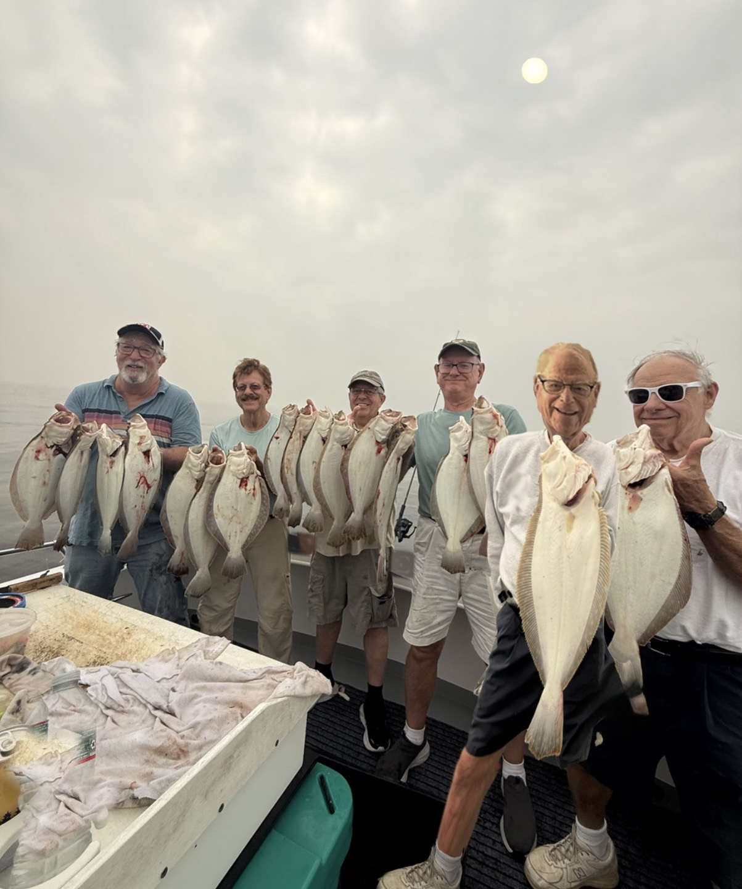

Golf
Committee: Gary Engelhardt, Gary Don, Paul Fazio, Mike Doherty, Giancarlo Bisone,
Paul Richert, Charlie Tuch, Len Manis, George Giaquinto, Don Peterfriend
Golf is the most popular of the Hobbyists activities with approximately 100 or more golfers participating each year from April through October. Foursomes are assigned to play on Tuesdays and Fridays. Tuesday golfers play 18 holes at a course selected at an area golf course by the captain of each foursome; Friday golfers play 9 holes at Orchard Hills in Paramus. Each month there is a Travel Tuesday where all who sign up participate at a course designated by the Golf Committee. There are also three golf tournaments for all golfers with prizes awarded to teams and/or individuals. Each year the golf committee arranges a 3-day golf trip to Atlantic City.

Gourmet Cooking
Jim McKeown, Jack Warner, Jim Atieh, Jim Cinquina, Co-Chairmen
Meet twice each year at a member’s home to enjoy meals they prepared. Each participant volunteers to cook a different part of the meal, i.e., appetizer, entrée, side dish, dessert.

Habitat for Humanity
Bob Becher, Chairman – bobpeg451@gmail.com, (201) 281-2874
There has been limited building activity in Passaic County, but in mid-summer there was the opportunity to perform some rehabilitation work on houses in Paterson. About 7-8 Hobbyists have been participating about once a month to assist in these projects. This activity should continue through the end of the year.

Hiking
Ed Lundell, Chairman - edlundell4@gmail.com, (612) 865-5381
Hiking through various trails and/or mountain venues in NJ and other regional areas. Contact Ed for details.

Hobbyists Dances
Bill Healy, Chairman - whealy3741@aol.com, (201) 264-3498
Gala dinner/dance celebrations twice a year. Contact Bill for information.

Hobbyists Concerned
Steve Rubin, Co-Chairman - srubin226@gmail.com, (201) 390-1220
Peter Philip, Co-Chairman - phphilip37@optonline.net, (201) 666-0105
Keeping Hobbyists apprised of recent Hobbyists and their families’ illnesses and/or deaths.

Investments
Ron Reedy, Co-Chairman – ronaldreedy@gmail.com, (917) 601-2108
Mike Flannery, Co-Chairmen – mikevflannery59@gmail.com, (201) 303-7315
Group members compare investment strategies.

Membership
Bob Mosher, Chairman – mosher895@aol.com, (201) 615-5603
Steve Hochman – Member Directory – shochman@gmail.com, (201) 424-9701
Current membership stands at 441. Age Breakdown: We have 62 members aged 90 or older, and 379 members under 90. Within our younger demographic, 38 members are under 70. Age Variance: Our oldest member is 99 years old, while our youngest is 61. Following a quiet summer, we welcomed 6 new applicants with an average age of 72.5. Year to-date, we have received 33 applications.

Military History
Tom Heed, Chairman – theed@ramapo.edu, (845) 534-8695
Presenations and discussion of military campaigns, strategies and achievements throughout the ages. Contact Tom for specific meeting dates and times.

Movie Lovers
Dick Oswald, Chairman – ddoswald@verizon.net, (201) 447-4053
Meet on the second Tuesday of each month at the Senior Lounge in the Ridgewood Village Hall.
A variety of classic as well as some lesser-known movies are presented and discussed along with production history and relevance in our society. Due to renovations at the Senior Lounge, we are on hold until December or January. Contact Dick for more information.

Music Lovers
Jim McKeown, Chairman – jimmckeown@optonline.net, (201) 327-3411
Second Friday of each month, 10 a.m. – noon. Members are encouraged to research and present a variety of music topics.

Navigating Retirement
Mitchell Milch, Chairman – mhmilch@gmail.com, (201) 647-6607
Navigating Retirement is designed to normalize and highlight opportunities and challenges most of us will face at some juncture as individuals and couples. We hope that these lively discussions will empower the members and offer them tools to more confidently negotiate these hurdles to achieve greater satisfaction, comfort and feelings of security. Contact Mitchell for details.

Pickleball
Alan Lo, Chairman – funnycpa@aol.com, (908) 447-6833
We play Mondays and Wednesdays at Saddle River Park in Rochelle Park from 8:30 to 11:00 a.m. weather permitting.

Picnic
Cliff Matthews, Chairman – cematth3ews0914@gmail.com, (551) 427-2617
Annual picnic held in August at Graydon Pool

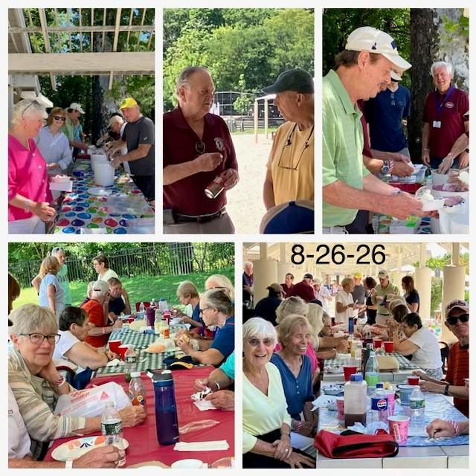

Pinochle
Jim Atieh, Chairman – atiehlj1@verizon.net, (201) 315-5346
We meet every Thursday at 9:15 a.m. at 27 Royal Street, Hawthorne. Open to beginners and players at all levels.

ROMEO
Cliff Matthews, Chairman– cematth3ews0914@gmail.com, (551) 427-2617
ROMEO meets monthly at a local restaurant. Members pay for their own meal but usually may bring their own wine and beer.

Science & Technology
Elliot Ratchik, Chairman – eratchik@gmail.com, (914) 420-4330
Presentation and discussion of topical issues relating to developments and discoveries and how they impact our work lives and personal lives. The Science and Computer club will continue this fall every third Wednesday beginning at 2 p.m. via ZOOM. We are looking for someone to replace Elliot as chairman. He will work with any replacement who is willing to serve and save this activity.

Tennis
Al Ianacone, Chairman – acianacone@gmail.com (973) 6501738
Indoor and outdoor playing, depending on the season. Contact Al for details

Trips and Tours
Bob Wong, Chairman – rtwdmd741@gmail.com, (201) 670-1814

Volunteer Service
Joe Hammer, Chairman – joseph.hammer@icloud.com, (201) 675-0651
Monthly volunteering at Eva’s Kitchen helping to prepare meals and serve homeless and/or those in need.

Walking
Alan Stein, Chairman – stampmavin1@verizon.net, (201) 693-0326
Gentle walking, usually in local parks. Less strenuous than hiking. Good exercise.

Wine Appreciation
Bob Stevenson, Chairman – robtstevenson@hotmail.com, (201) 615-1202
Meet at selected local restaurants to enjoy a meal with various wines. Check with Bob for frequency of meetings.

Winemaking
Paul Richert, Chairman – phriche7314@gmail.com, (201) 723-8921
Contact Paul for details of upcoming events.

World Affairs
Don Togneri, Chairman – donaldtogneri@gmail.com, (908) 347-2820
World Affairs kicked off its season with a ZOOM meeting on Wednesday, Sept 9 at 2 p.m. The topic, World News, revisited English-language news sites around the world to get a sense of how other countries view some current events:
Iran conflict / Hormuz - impact on world energy markets
Ukraine conflict - impact on fertilizer and food
Venezuela - oil
Spain - Cueta border crash

Next Hobbyists General Meeting – Thursday, October 1, 2026
Please continue to check your email regularly for information on upcoming events for each activity
Be Kind
Hobbyists Newsletter Staff
Rick Pascal, Editor-in-Chief - rickpas@optonline.net , (201) 208-7191
Steve Rubin, Associate Editor - srubin226@mail.com, (201) 390-1220
Mark Singer, Proofing Editor - msinger@ramapo.edu, (201) 446-6809
Mike Doherty, Distribution Manager - mikedoh@aol.com, (201) 675-4614

