Hobbyists Newsletter
Summer Edition
July - August 2026

President – Peter Weinstein First Vice President – Steve Friedman
Second Vice President – Chuck Woehrle Secretary – Dick Boswell
Treasurer – Gary Engelhardt Church Liaison – Lew Dickinson
Sponsored by the First Presbyterian Church, Ridgewood, NJ
http://www.hobbyists-unlimited.com
Club Activities

Due to the extensive details in the recent 60th Anniversary Newsletter, this Summer Newsletter will be significantly curtailed, showing only Hobbyists highlights.

Membership
Chairman: Bob Mosher. Committee Members: Ed Daly, Steve Hochman, Paul Daniele,
Steven Fonder, Cliff Matthews (shirts and hats).
For membership questions, contact: hobbyistsmembership@gmail.com

Archive
Joe Suplicki, 201-316-3262, jssuplicki@aol.com.

Audio/Visual
Bob Mosher, 201-689-9651, rmosher895@aol.com, Ed Daly, 201-447-4603, eddaly386@yahoo.com.
Beer Appreciation 
This Photo by Unknown Author is licensed under CC BY-NC
Rick Rosenthal, rickcrosenthal@icloud.com, 201-675-1870.

Blackjack 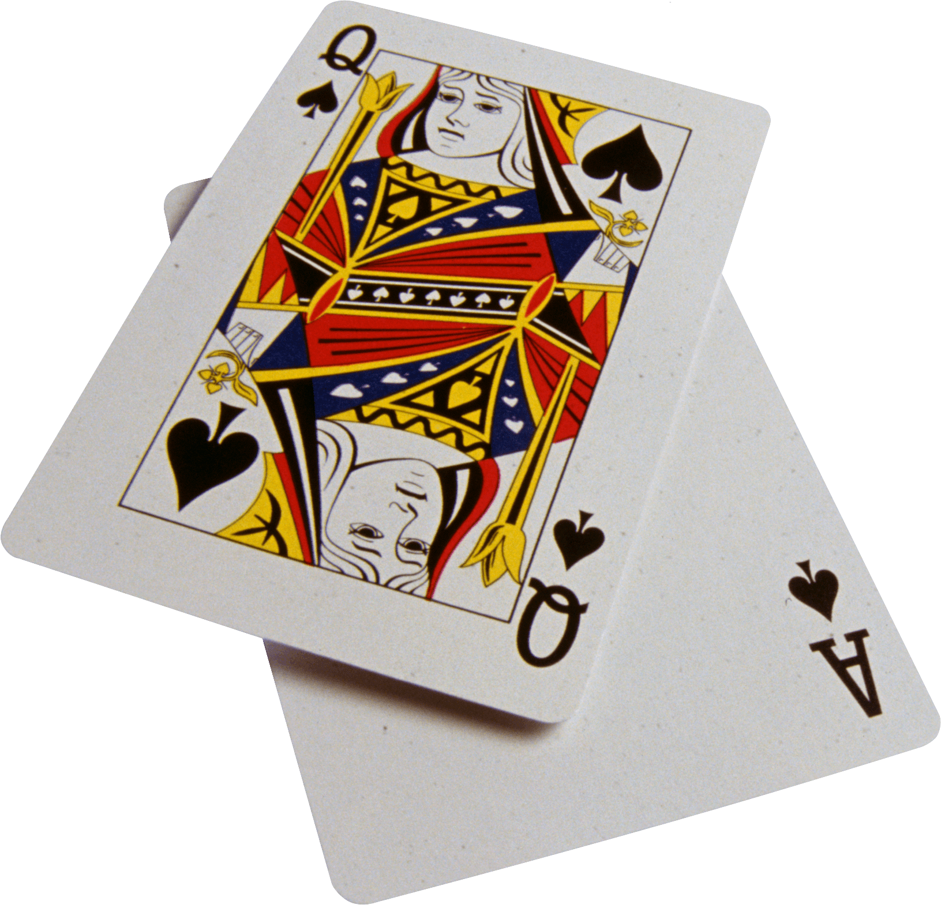
This Photo by Unknown Author is licensed under CC BY-NC
Ray Litwitz, 973-714-9019. Blackjack will continue to meet on the second and fourth Thursday in July and August at noon. Contact Ray at: raylitwitz@gmail.com if interested.

Bocce 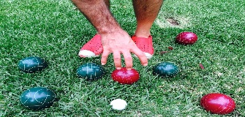
This Photo by Unknown Author is licensed under CC BY-SA-NC
Steve Friedman, 201-916-6079, stefri4@yahoo.com. The bocce boys meet every Friday from 9:30 to 11:30 am at Borough Park in Waldwick. We will be playing throughout the summer.

Book Club 
This Photo by Unknown Author is licensed under CC BY-ND
Jon Sterling, jbsterling@optonline.net, Pat Donohue, pjdonohue1221@gmail.com).
Bowling 
Gary Don, 201-574-3506, garydon3@verizon.net, Don Peterfriend, 201-739- 8672, dpeterfriend@yahoo.com, Mark Singer, 201-446-6809, msinger@ramapo.edu,
Bill Raftery, 201-527- 8585, mrbill357@verizon.net, Bob Mosher, 201-615-5603, rmosher895@aol.com. Hobbyists Bowling continues throughout the summer at Montvale Lanes each Monday at 9 a.m. Members who wish to bowl in the Fall should contact a Bowling Committee member if they haven’t already signed up recently.
Hobbyist Gary Bright recently bowled a 300 game at a practice at Montvale Lanes. The perfect game was part of a 719 series—both career highs. Gary is captain of the Hurricanes, one of 15 teams that compete in the Hobbyists Bowling League that will resume in September.

Congratulations to the Sharks, Hobbyists Bowling League 2025-26 champions.
From l. to r., Les Andersen, Bob Paoili, Captain Bill Raftery, and Wayne Lemme.
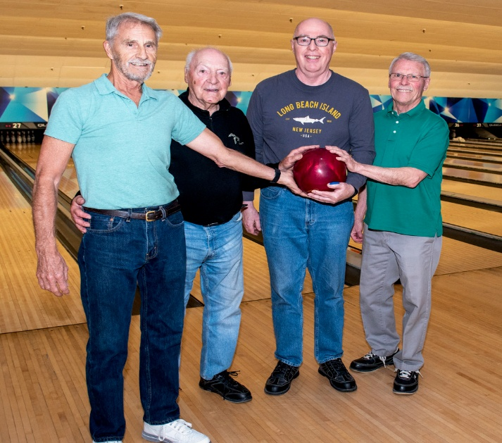

Bridge 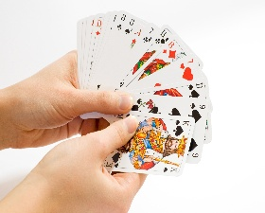
Mike Murphy, 201-334-7284, mgmclbchp@gmail.com. Ray Chuebon, 201-652- 4586.
Duplicate Bridge played at the church, every Thursday from noon to 3 p.m.

Camera 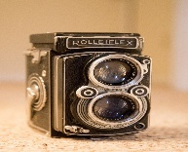
Tom Heed, 845-534-8695, theed@ramapo.edu, Mark Singer, msinger@ramapo.edu.

Chess 
Rick Pascal, Chairman, 201-208-7191; rickpas@optonline.net, Jeff Kresky, 201-965-5078, kreskyj@wpunj.edu. We meet in the church from 9:30 a.m. until noon September through June. In July, we play outdoors in one of the Bergen County Park picnic areas in Ridgewood. Contact Jeff Kresky for details. Word of our Chess Club’s success has reached the Chess Club at Wanaque Reserve. They challenged us to a tournament, tentatively scheduled for Saturday morning, July 11th. We’ll let you know how we did.
Computer 
There is interest in resurrecting the Computer Club. Contact Bob Stevenson, 201-615-1202, robtstevenson@hotmail.com, to share information and if you would like to chair the activity.

Cribbage 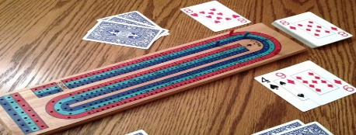
This Photo by Unknown Author is licensed under CC BY-SA-NC
Cribbage is our newest activity. Contact Don Dexter or John Peterman for details.

Dances
Bill Healy, 201-652-5868, whealy3741@aol.com, Gary Engelhardt, 201-670-9185, garye569@msn.com, Bob Mosher, 201-615-5603, rmosher895@aol.com.

Discussion Group 
Mitchell Milch, 201-647-6607, mhmilch@gmail.com. We will resume meeting on Wednesday, September 2nd at First Presbyterian Church where we congregate for coffee at our General Meetings. All interested parties are welcome to contact Mitchell at mhmilch@gmail.com.

Fishing 
Gene Boyle, 973-703-9065, gbrealty@optonline.net, Peter Weinstein, 201-663- 3536, rodnreel44@aol.com. The Hobbyist Fishing Club has completed a successful Lake George fishing trip. Steve Weinstein, Ron Reedy, Bob Wong, Steve Miezeiewski and Peter Weinstein all caught nice bass, pictured below:

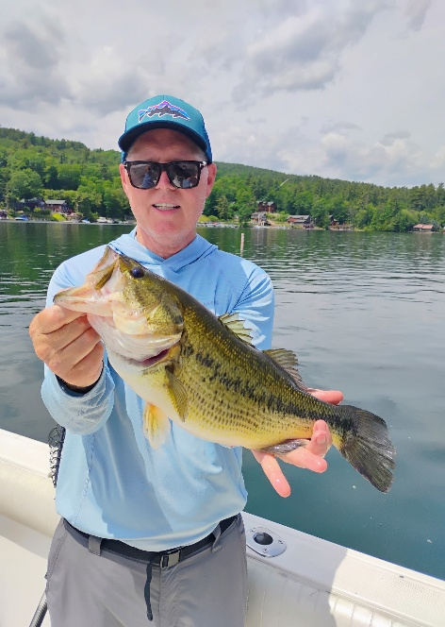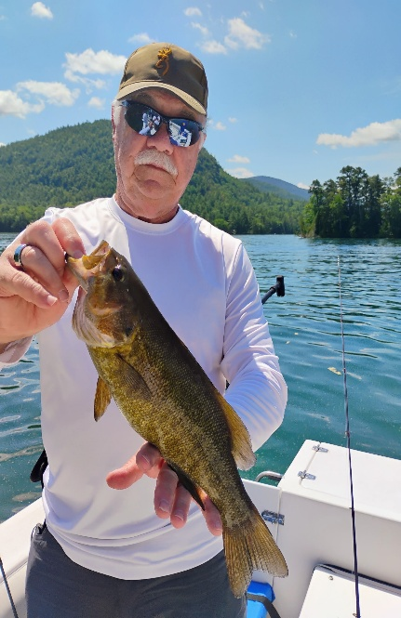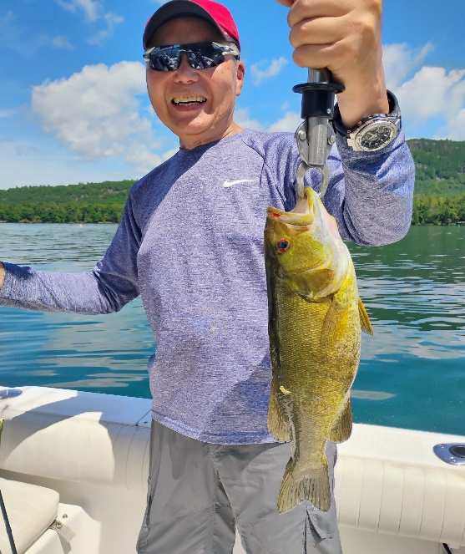
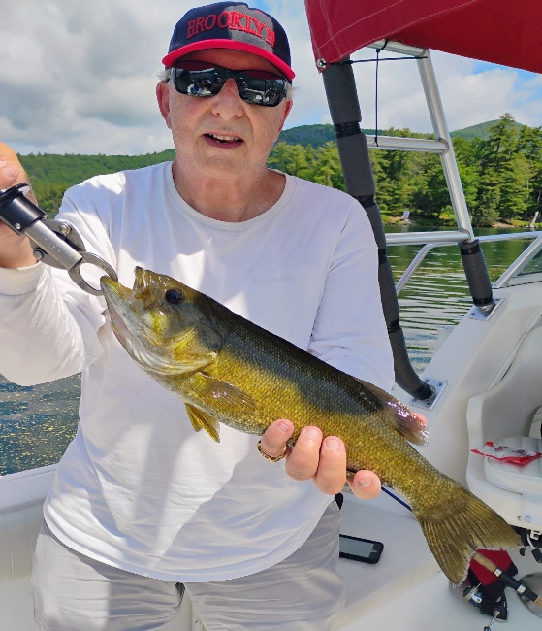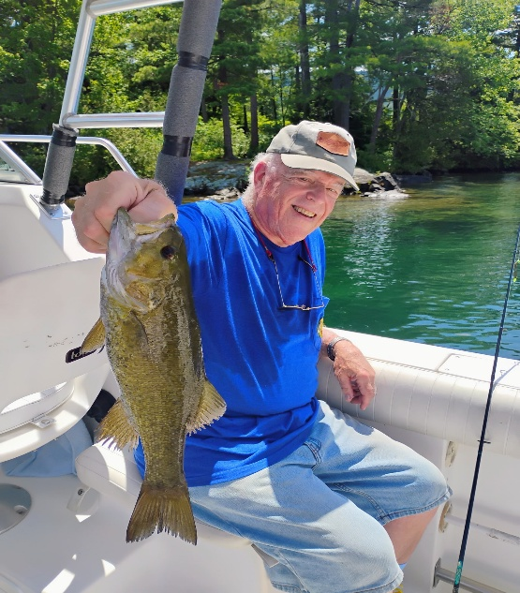

Golf 
Gary Engelhardt, Gary Don, Paul Fazio, Mike Doherty, Giancarlo Bisone, Paul Richert, Charlie Tuch, Len Manis, Stu French, Sid Sobel, George Giaquinto, Don Peterfriend, Ed Dowd.
Summer Tournament - July 14 - Chairmen - Gay Engelhardt and Don Peterfriend.
Late Summer Tournament - August 11 - Chairmen - Gary Engelhardt and Len Manis
For full details and to sign up go to the Golf Club section of the Hobbyists website.

Habitat for Humanity 
Bob Becher, 201-281-2874, bobpeg451@gmail.com. Watch your email for volunteer activity.

Hiking 
This Photo by Unknown Author is licensed under CC BY-SA-NC
Ed Lundell, 612-865-5381, edlundell4@gmail.com. After meeting at Graydon Pool, the Hiking Club visits local sites each Tuesday and Friday morning.

Hobbyists Concerned
Peter Philip, 201-666-0105, pjphilip37@optonline.net. Steve Rubin, 201-390-1220, srubin226@gmail.com

Hobbyists Songs 
This Photo by Unknown Author is licensed under CC BY-NC

Steve Friedman, 201-916-6079, stefri4@yahoo.com and Dick Boswell, 201-264-5180, rbozz55@gmail.com. We write and record whimsical parody songs examining Hobbyist sports and other activities, notable Hobbyist members, and the joys and challenges of aging.
Investments 
Ron Reedy, ronaldreedy@gmail.com, Mike Flannery, mikevflannery59@gmail.com. YTD, the Investments Group has held two quarterly meetings January and April. We have approximately 25 members and 12-15 routinely attend any one meeting. We follow a standard agenda:
- Markets Review
- Guest Speaker/Special Topic
- Investment Competition Scorecard
- Review of Interesting Articles
- Open Forum / Q&A
Our next meeting (Zoom only) is scheduled for July 22 at 1:30 pm. Among the topics will be a review of the SpaceX IPO.
Lastly, a big thank you and speedy recovery to Ed Daly, without whose help, the technical issues we experienced from time to time would have been far worse. Thank you, Ed!

Italian Club 
This Photo by Unknown Author is licensed under CC BY-SA
Don Togneri, 201-445-0679, dj2dm2@hotmail.com.
Jazz Bunch 

Bob Stevenson, 201-615-1202, robtstevenson@hotmail.com. The Hobbyists Jazz Bunch consists of Hobbyists who enjoy all forms of jazz and swing music and periodically attend interesting concerts in the metro NY/NJ area.

Lunch Bunch Sunday 
This Photo by Unknown Author is licensed under CC BY
Bob Sayegh, 201-670-6010, bobsay14@gmail.com.
Military History 
Tom Heed, 845-534-8695, theed@ramapo.edu.

Movie Lovers 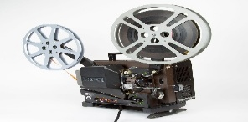
This Photo by Unknown Author is licensed under CC BY-SA-NC
Dick Oswald, 201-447-4053, ddoswald@verizon.net. We schedule one movie each month except July and August at the Ridgewood Village Hall.

Music Lovers
This Photo by Unknown Author is licensed under CC BY-NC
Jim McKeown, 201-327-3411, jimmckeown@optonline.net. Second Friday, 10 a.m. at the church. The May program was presented by Rick Rosenthal and covered Rogers & Hart. There is no programming during June, July, and August.
Pickleball 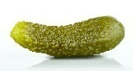
Alan Lo, 908-447-833. Pickleball is played outdoors during the spring, summer and fall.

Pinochle 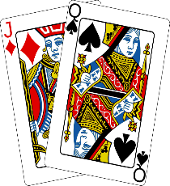
This Photo by Unknown Author is licensed under CC BY-SA
Jim Atieh, 201-315-5346, atiehlj1@verizon.net. We meet every Monday & Thursday in the clubhouse at the Hovnanian condos in Mahwah just off Route 17 North. We play from 10 a.m. to 3 p.m. with a break for lunch. We are more than happy to teach anyone how to play.

Poker 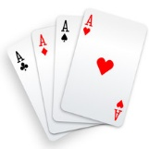
Dan Wolf, 201-825-7769, danlwolf@optonline.net. We meet every Friday at members' homes. On alternate Fridays we play Texas Hold'em then Hi-Lo Poker the following week. Hold'em is limited to eight players due to homeowner's table size. Hi-Lo Poker is limited to seven players.

ROMEO 
This Photo by Unknown Author is licensed under CC BY-NC
Cliff Matthews, 201-447-9040, cematthews0914@gmail.com. ROMEO meets at different moderately priced BYOB places on the third Friday of the month and is a pleasant way to meet and socialize with fellow Hobbyists.

Science &Technology 
This Photo by Unknown Author is licensed under CC BY-SA
Elliot Ratchik, 914-420-4330, eratchik@gmail.com.

Tennis 
Al Ianacone, 973-650-1738, acianacone@gmail.com, Bob Kozar, bkozar1@aol.com. Tennis is played at the Fairlawn Racquet Club on Mondays from 12 noon until 1:30 p.m. September through May. There is no program throughout the summer months.
Trips & Tours (Day) 
This Photo by Unknown Author is licensed under CC BY-SA
Bob Wong has stepped up to become Chairman and resurrected this program. He is planning a trip to Gardens for Sculpture for Wednesday, June 24.
Trips & Tours (Extended) 
There are no current plans for extended trips and/or tours at this time.
Volunteer Service
Joe Hammer, 201-675-0651, joseph.hammer@icloud.com. The club has been traveling to Eva’s Village in Paterson on two Tuesdays per month to aid in the set-up, service and clean-up of two seatings of a hot, nutritious lunch for the homeless and working people in need in the surrounding area. Fourteen Hobbyists participate as active members of the Club with six to seven of us going to Eva’s on a given Tuesday.

Walking 
Alan Stein, 201-447-4235, stampmaven1@verizon.net, Mark Singer, 201-446- 6809, msinger@ramapo.edu. The Thursday Walking Group continues to thrive, walking from the Ridgewood Duck Pond to the Dunkerhook area and back on the Saddle River Trail, a distance of four miles. The walk entails both good exercise and brilliant conversation. We encourage more walkers to join us.
Wine Appreciation 
Bob Stevenson, 201-615-1202, robtstevenson@hotmail.com. The Wine Appreciation Group (WAG), a long-standing Hobbyist activity, meets for lunch and wine tasting on a bi-monthly cycle, excluding July and August.

Winemaking 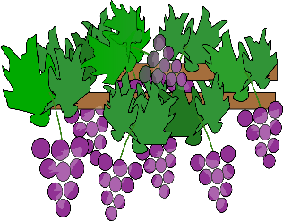
Paul Richert, 201-967-1347, phriche7314@gmail.com. On May 11th, members of the Hobbyist winemakers club went to the winery - The Wine Experience - in Tinton Falls.
On Monday, July 20th our Montepulciano wine will be ready for bottling. Again, we will drive to the winery, carpooling from the Graydon Pool parking lot in the area along Northern Parkway at the far end behind the soccer field (hidden by the trees). I want to thank the Hobbyists members who have participated in making wine over the years. Overall, our winemaking has been a total success. Those Hobbyists who participate find this activity to be both entertaining and rewarding.
World Affairs 
This Photo by Unknown Author is licensed under CC BY
Don Togneri, 908-347-2820, dj2dm2@hotmail.com. ZOOM meetings only.

Constant Contact
Ed Daly, 201-447-4603, eddaly386@yahoo.com. If you are creating an email using Constant Contact, you will need to have an access code for your first use. The codes are user-specific. Call Ed Daly to get your code for your first use.
Notice
Valley Hospital presents a roundup of the latest events taking place throughout the year which may be of interest to you. If interested, go to ValleyHealth.com/Events.

Hobbyists Alert 
This Photo by Unknown Author is licensed under CC BY-SA
If you ignore robo-calls from a Caller ID that you don’t recognize, you may be missing important calls from the Hobbyists. The service we use is CALLING POST, although at times the calling number with an area code of 405 is used instead. So, unless you have voicemail or an answering machine, we suggest you take the call.

Note From the Editor
As we ease into the summer months, many of us will be heading outdoors for more activities. Just remember to wear appropriate sunscreen and stay hydrated during recreation. Stay well, healthy, and enjoy the summer. See you at the next Hobbyists General Meeting in September. All the best for a wonderful summer.
Rick Pascal
Hobbyists Newsletter Staff
Rick Pascal, Chairman/Editor (201-791-9526, rickpas@optonline.net), Steve Rubin, Composition, (201-390-1220, srubin226@gmail.com) Ed Daly, Review, (201-447-4603, eddaly386@yahoo.com), Mark Singer, Review, (201-446-6809 msinger@ramapo.edu), Mike Doherty, Distribution (201-675-4614, mikedoh@aol.com)

